# IF THE DOCUMENT IS NOT STRICTLY IN THE FORMAT, IT WILL BE AUTOMATICALLY REJECTED.

Book Title (Initial capital letters only, Garamond 16)

Example: University Physics

Chapter Title (Initial capital letter only, Garamond 14)

Example: Chapter 2: Kinematics.

ISBN: We process it at the Editorial

Edition: First, Second (as the case may be)

Publisher: AutanaBooks SAS

Publication Date:

Authors: Surname Name, Surname Name, Surname Name.

AUTHOR INFORMATION (Up to 6 authors)

The photo must be in color and high resolution, passport type, frontal.

**Albert Einstein,** a German physicist of Jewish origin, later naturalized Swiss, Austrian and American. He is considered the most important, well-known and popular scientist of the 20th century.

ORCID:

Mail:

Institutional Affiliation:

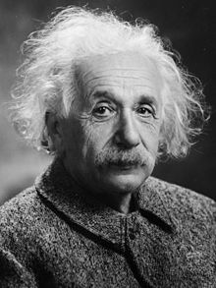

PROLOGUE (AUTHOR'S OPTIONAL)

CHAPTER TABLE OF CONTENTS (AUTHOR'S CHOICE)

The book chapter must be a maximum of 25 single-spaced pages, font size 11.

## INTRODUCTION

### Include a brief introduction to the chapter of the book, briefly specify what the chapter is about, what chapter number it is, how many additional chapters there are, reason for making the book. The document must be a maximum length of 25 pages.

DEVELOPMENT **(This title may vary depending on the case and the characteristics of the chapter)**

Text in Garamond number 11

1. *Subtitles* (Initial capital letters only. Do not increase indentation)

REFERENCES (Centered)

The text of the chapter may mention the names of persons, institutes, etc., without the need to cite them. You can place a super index and its corresponding footnote if required.

References may include any material consulted, even if it is not cited. The standards for citations and references will be IEEE standards. The use of the Word manager for citations and references is suggested.

**GENERAL PROVISIONS:**

The chapter of the book must have a maximum of 25 pages, following the format of the journal.

It must have a maximum of 6 authors.

Font size: 11.

Typeface: Garamond.

Spacing: 1.15.

Margins: left: 3cm; All others: 2cm.

* All images will be processed, as figures. All the figures must be vectorized. The title must go at the bottom. You must make references to it in the text before the figure.

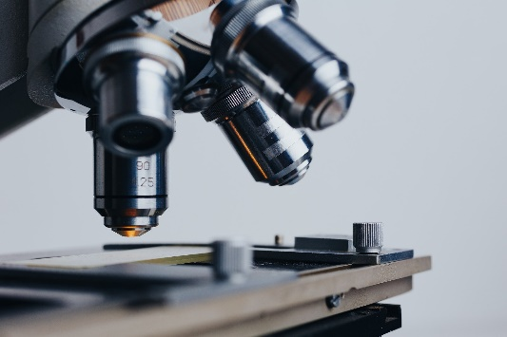

Figura 1. Microscope.

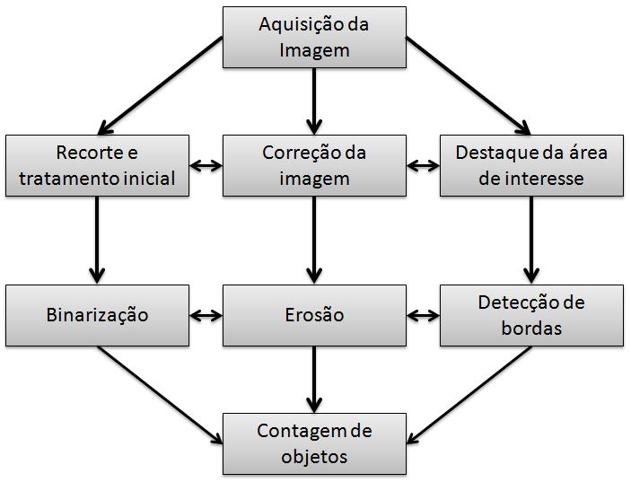

Figure 5. Operating diagram

State the subheadings of the figures below them; Place the table titles at the top. If your shape has two parts, include the labels "(a)" and "(b)" as part of each section.

* The labels on the axes of figures are often a source of confusion. Use words instead of symbols.
* Preferably write in the third person and with technical-scientific language.
* For the tables, consider that they must all be useful for research. Place the table titles at the top. Do not place subtitles in "text boxes" or in any other modality inserted in the figure. The tables are numbered with Roman numerals.
* The labels on the axes of figures are often a source of confusion. Use words instead of symbols.

Table 1. Comparison of results obtained.

|  |  |  |
| --- | --- | --- |
| Heading level | Example | Font size and style |
| Title (centered) | **Lecture Notes** | 14 point, bold |
| 1st-level heading | **1 Introduction** | 12 point, bold |
| 2nd-level heading | **2.1 Printing Area** | 10 point, bold |
| 3rd-level heading | **Run-in Heading in Bold.** Text follows | 10 point, bold |
| 4th-level heading | *Lowest Level Heading.* Text follows | 10 point, italic |

REFERENCES

All citations and references must be in IEEE format. A maximum of 25 references is accepted